**Configuring hive in zeppelin using default settings:**

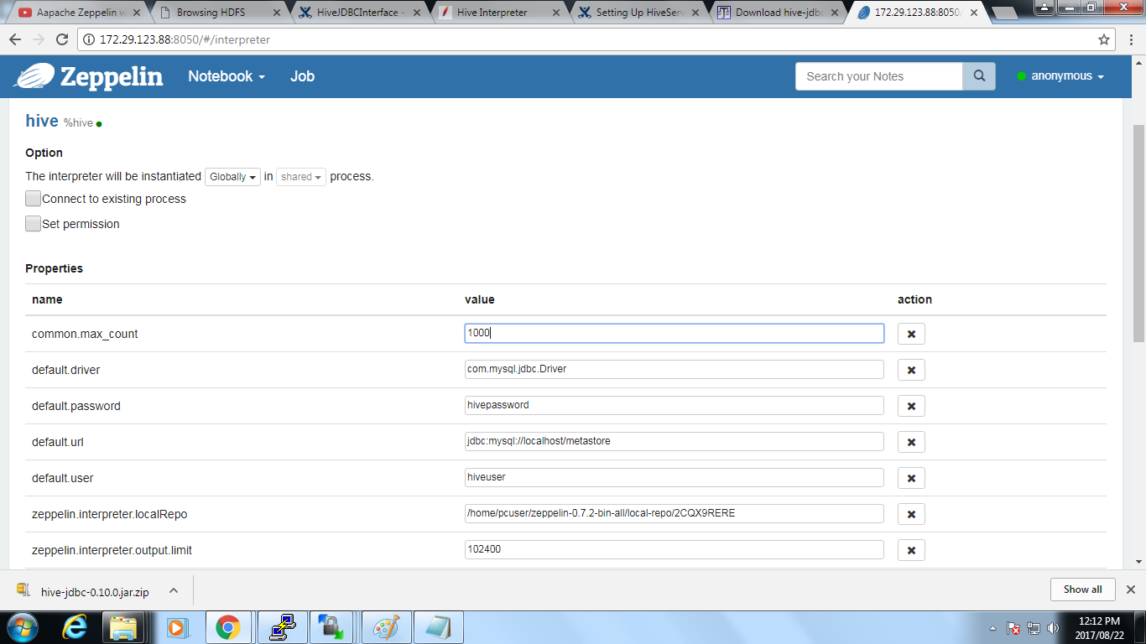

**Accessing mysql tables using hive:**

**Hive commands:**

Show databases;

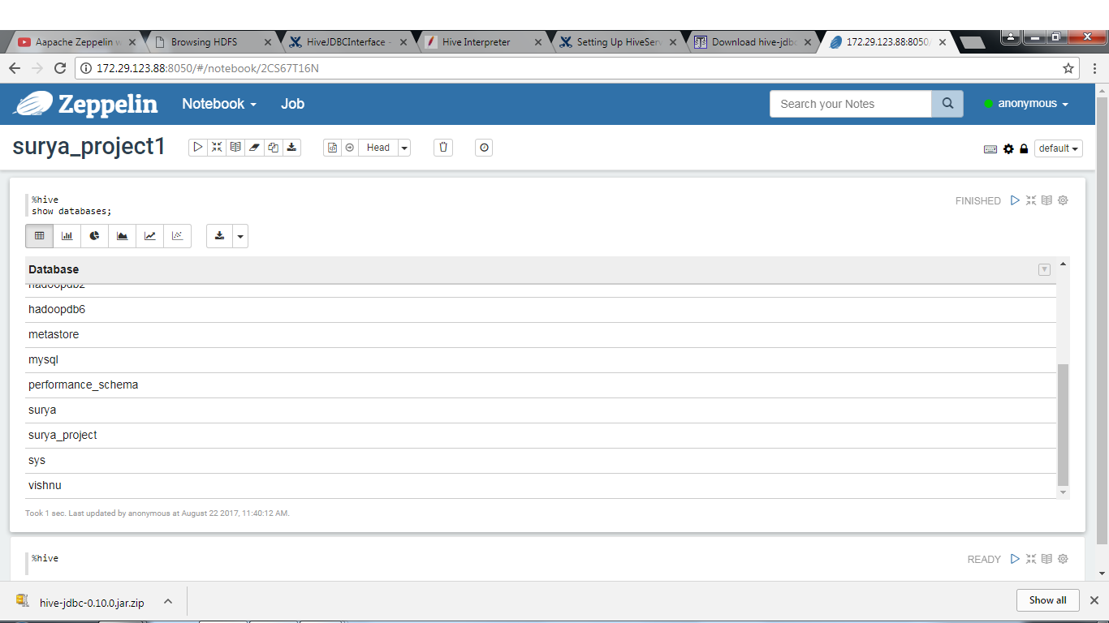

Show tables; 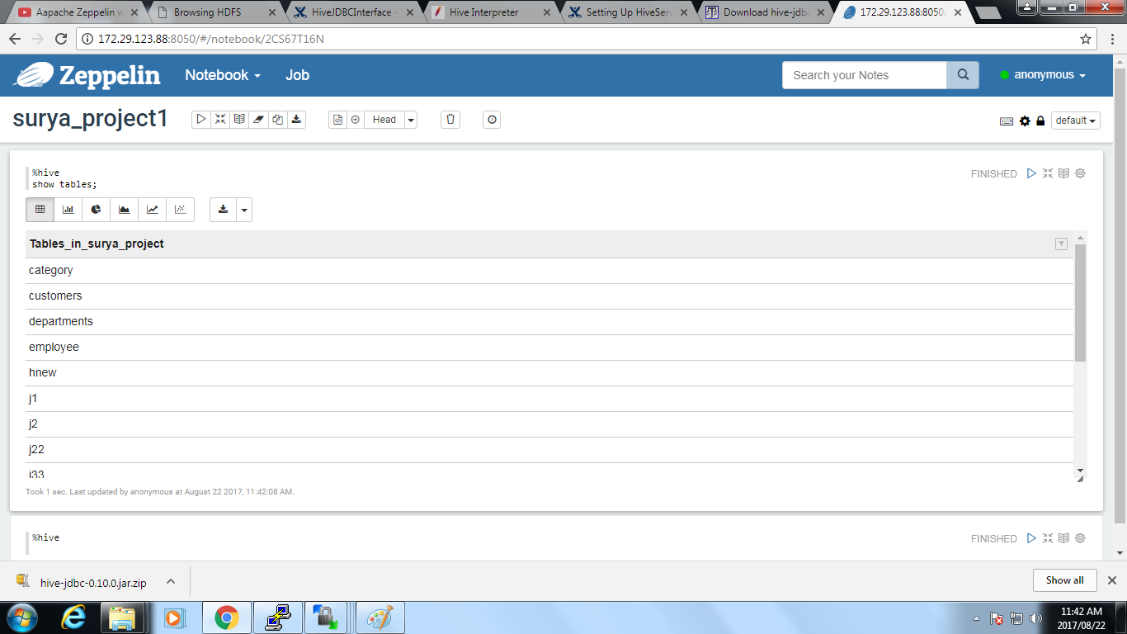

**Use surya_project;** 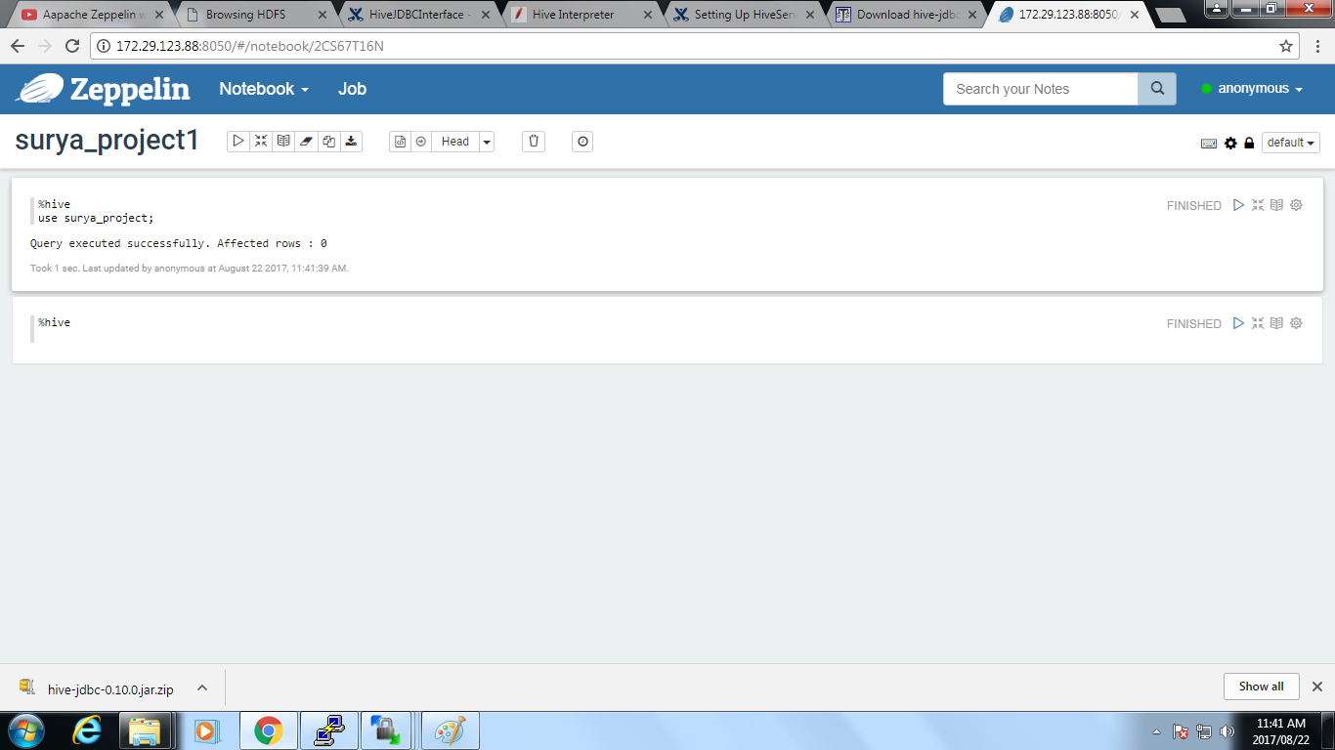

**Hive table using history data:**

//creating a hive table using the local history that is stored in a csv file.

create table surya_project(URL string,Title string,Visited_On string,Visit_Count int,Typed_Count int,Referrer string,Visit_ID int,Profile string,URL_Length string,Transition_Type string,Transition_Qualifiers string) row format delimited fields terminated by ',' lines terminated by '\n' tblproperties ("skip.header.line.count"="1");

load data local inpath '/home/pcuser/surya/surya_project.csv' into table surya_project;

select * from surya_project

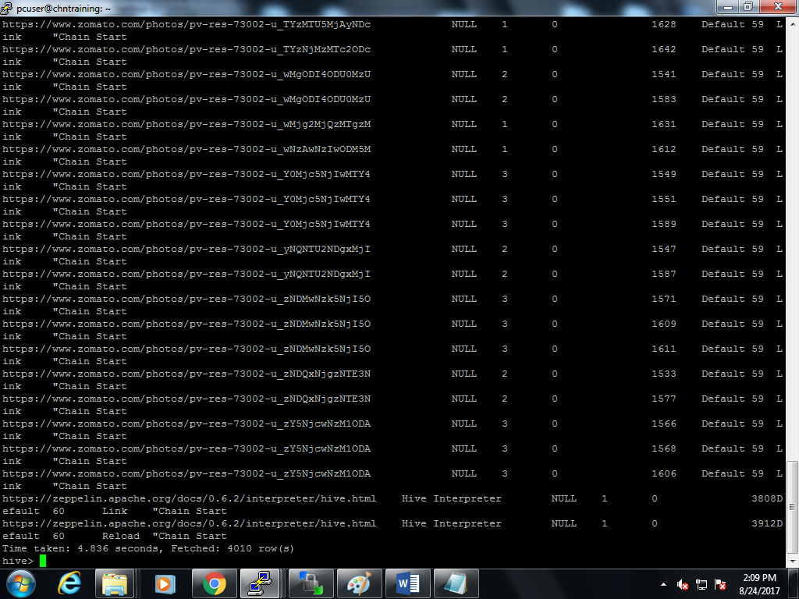

Select the url,title and the visited date and time from the stored hive table:

Select url,title,visited_on from surya_project;

